**PROJECT DEVELOPMENT PHASE**

SPRINT 4

* **Train The Model On IBM**

### 1.Register For IBM Cloud

### 2. Train Model On IBM

### TOPIC : AI powered nutrition analyzer for fitness enthusiasts

**Team id** : PNT2022TMID15800

In this milestone, we made Deep Learning Model Using the IBM cloud.

### Register For IBM Cloud

### IBM Account :

### Register link : <https://www.ibm.com/academic/home>

### Log in : <https://cloud.ibm.com/>

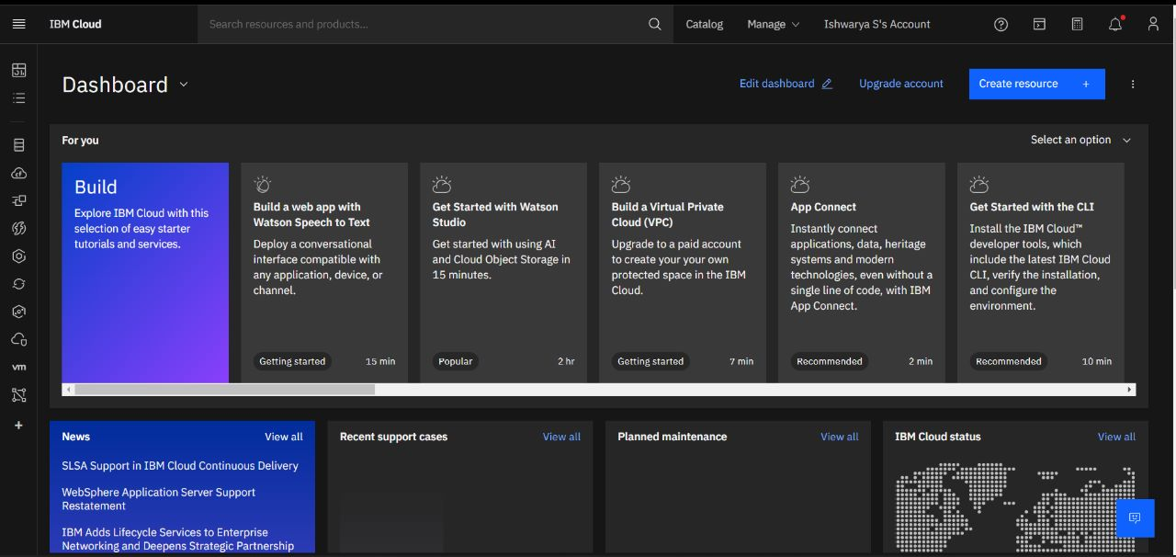

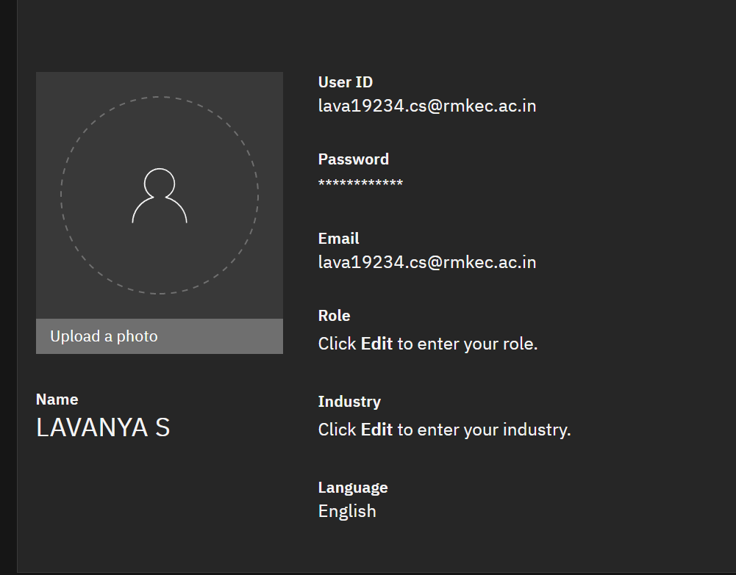

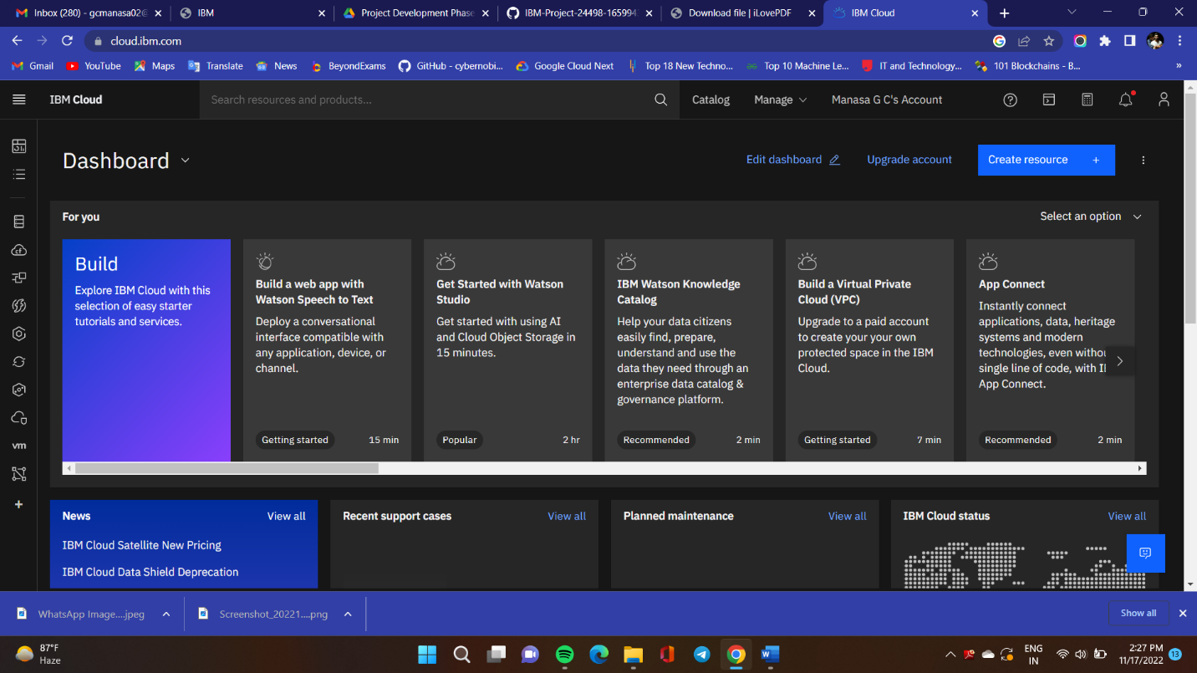

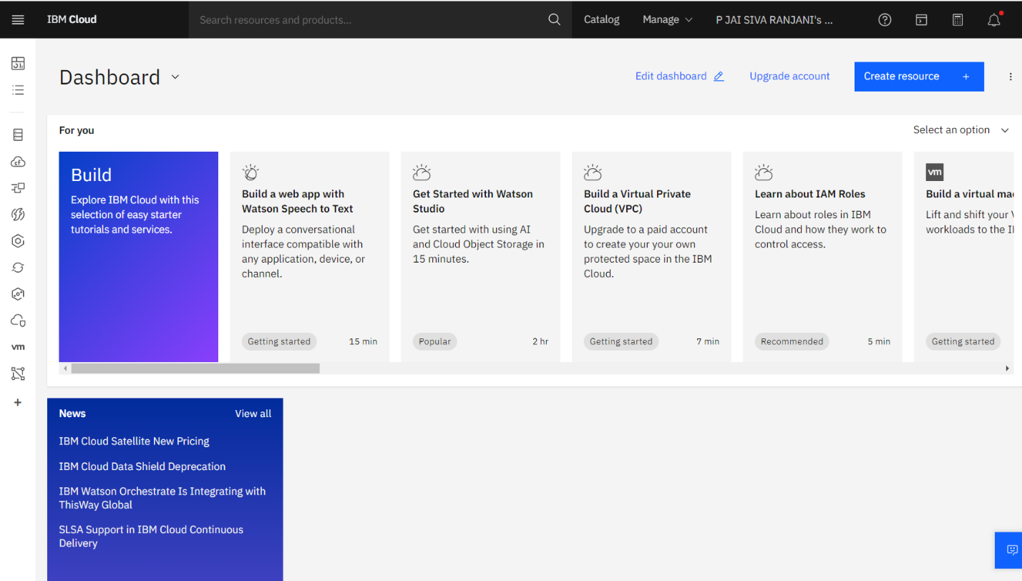

Train Model On IBM

Login to ibm cloud and create ibm Watson studio to train the model on ibm. Copy the file, paste it and run the file in notebook.

